# 2024.09.03(노트북에 설치)

# MySQL 설치

cf. https://code-angie.tistory.com/158

## 다운로드

https://downloads.mysql.com/archives/installer/

Windows (x86, 32-bit), MSI Installer / Apr 15, 2024 296.1M /(mysql-installer-community-8.0.37.0.msi)

hpalman@gmail.com / hM**D***@!*2

https://dev.mysql.com/downloads/windows/installer/

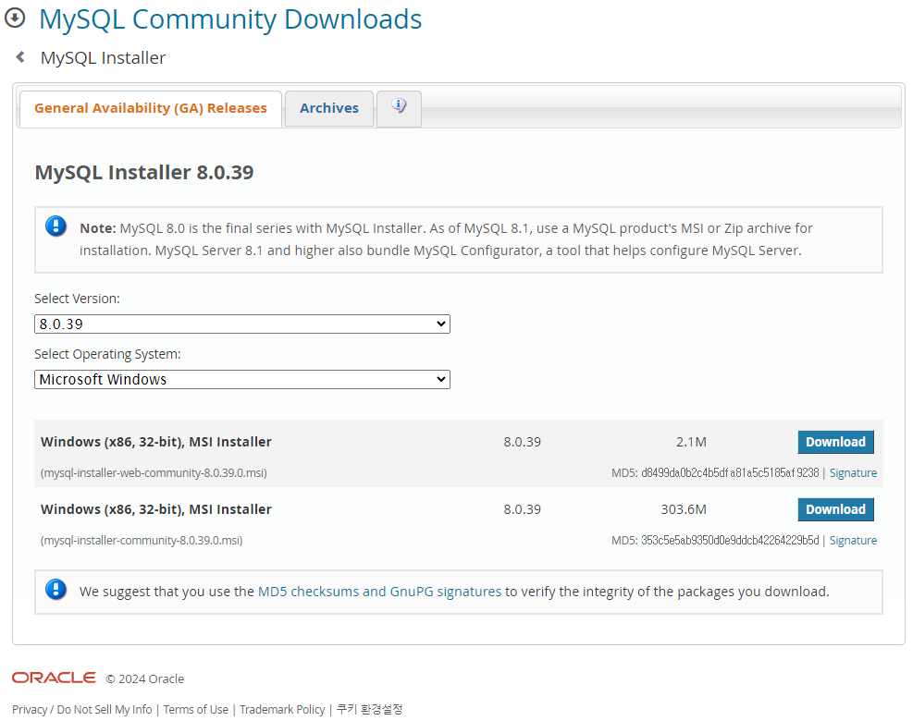

## 설치 과정

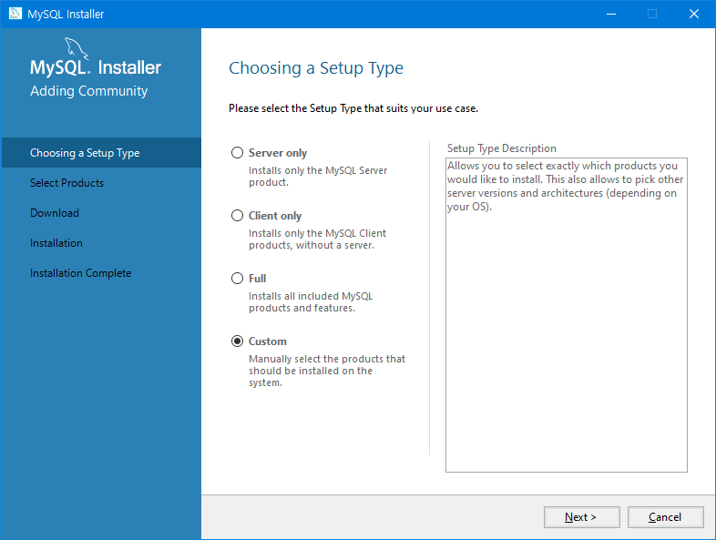

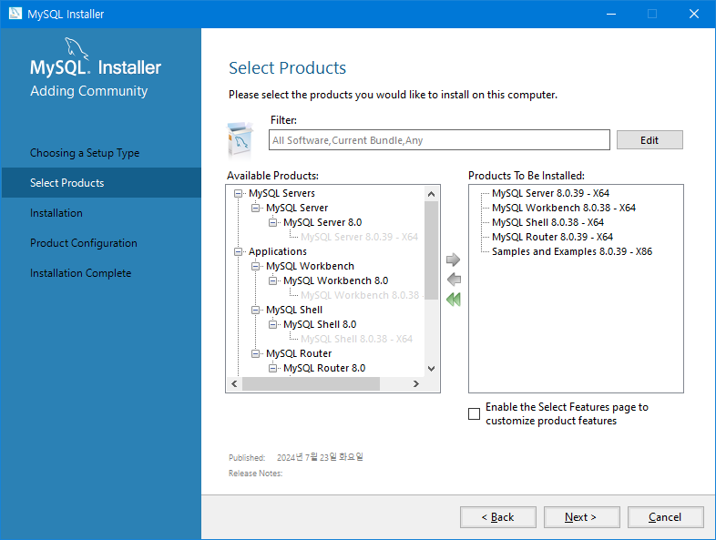 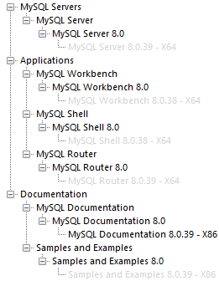

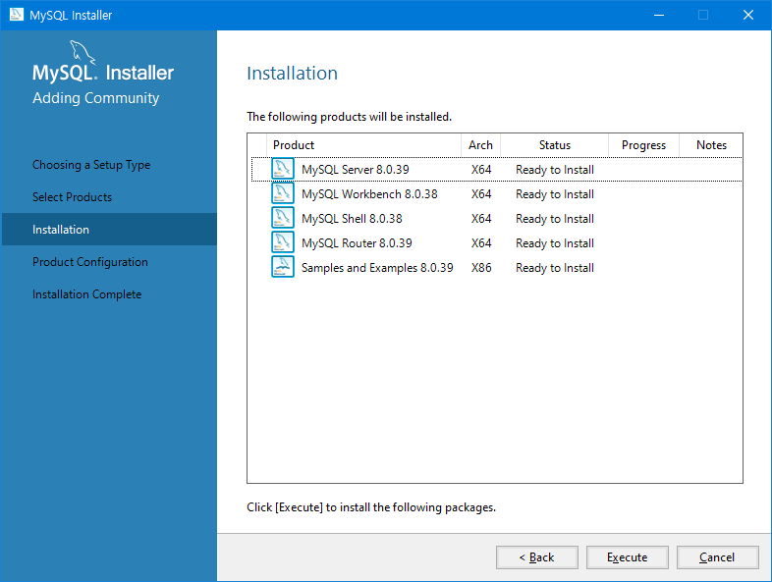

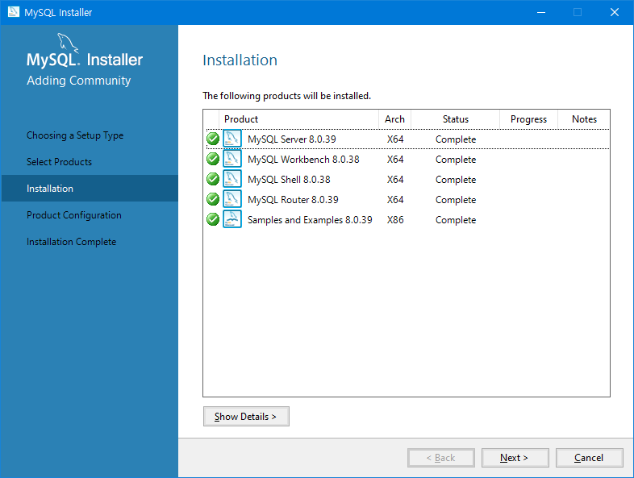

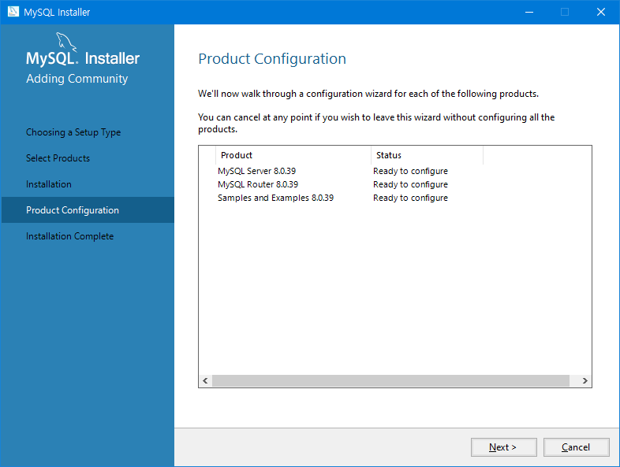

3306 > 3386

33060 > 33860

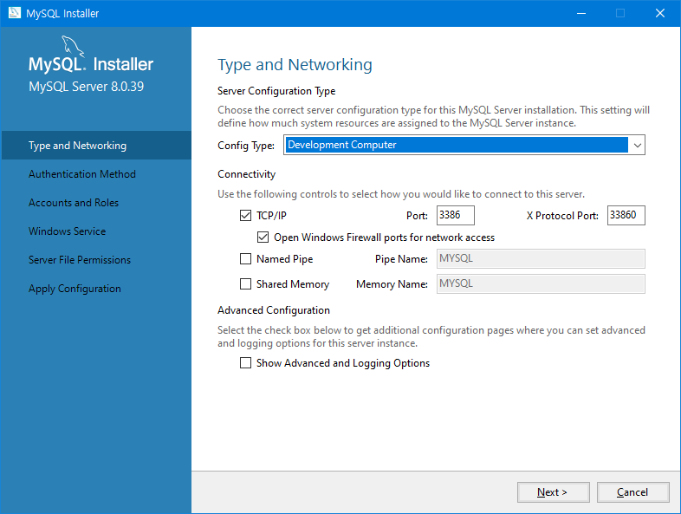

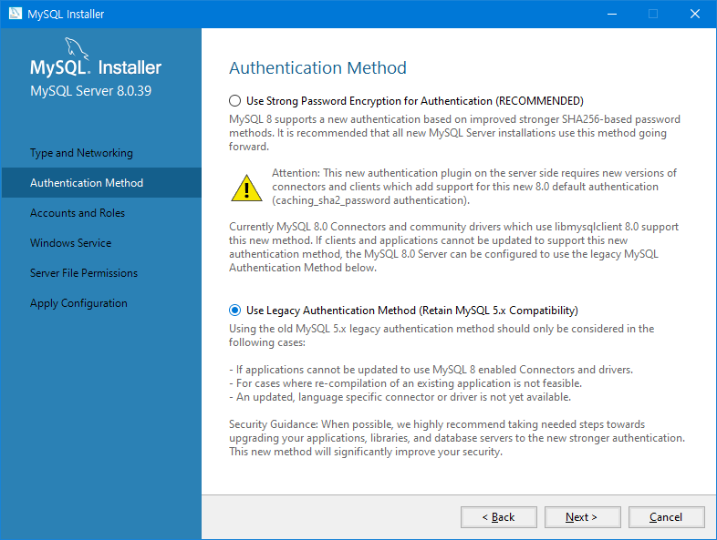

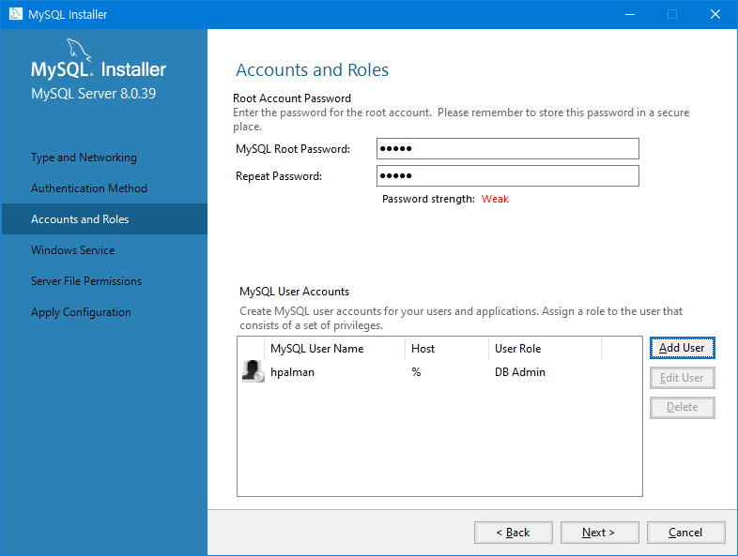

MySQL Root Password > mysql

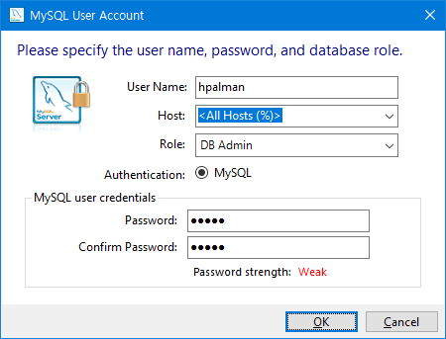

hpalman / mysql

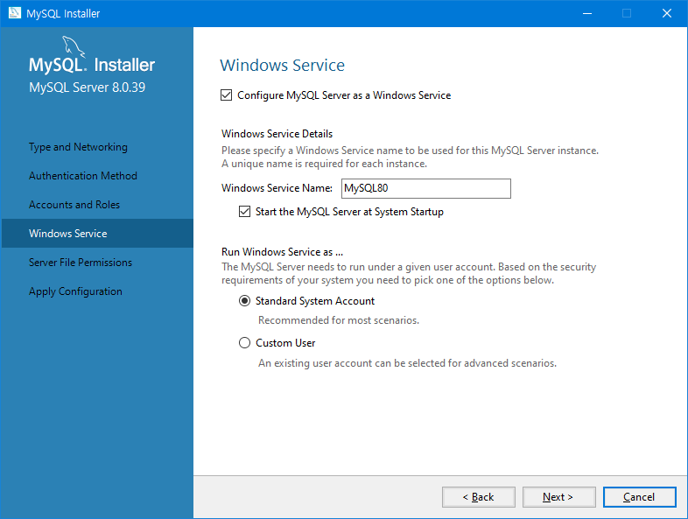

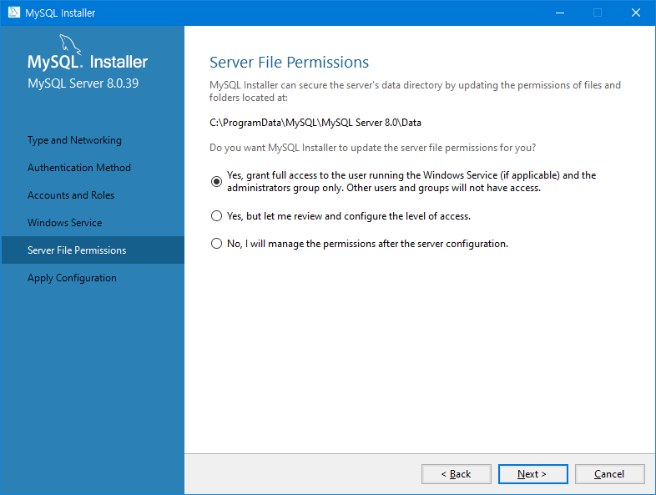

### Apply Configuration

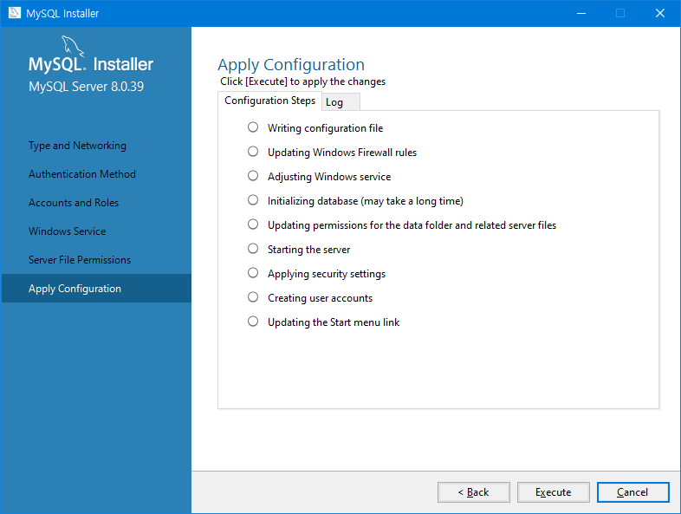

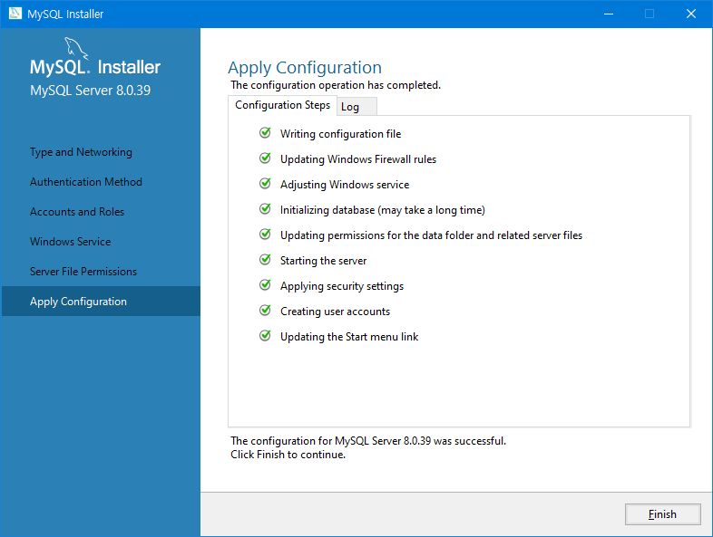

### Product Configuration

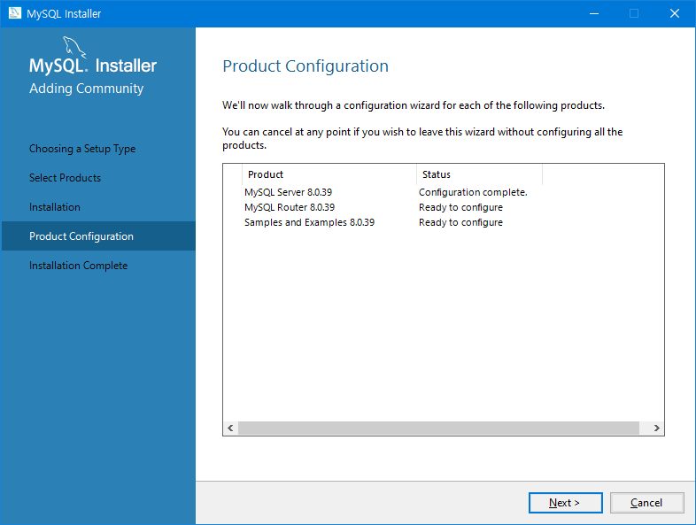

### MySQL Router Configuration

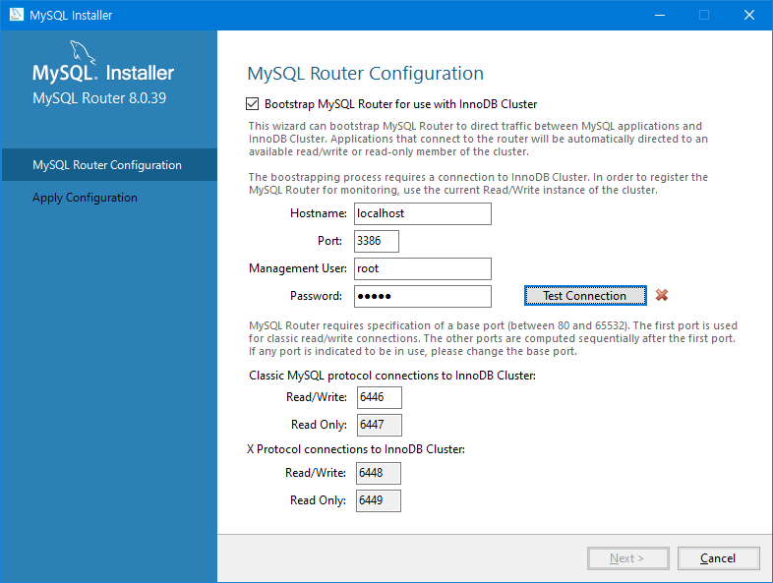

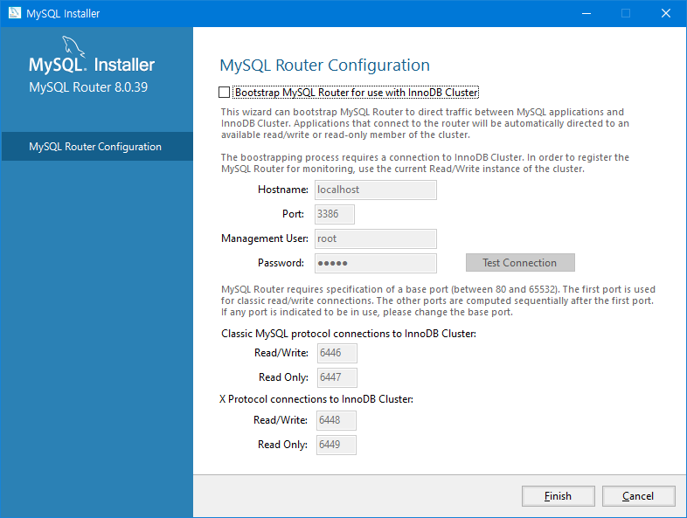

### Connect To Server

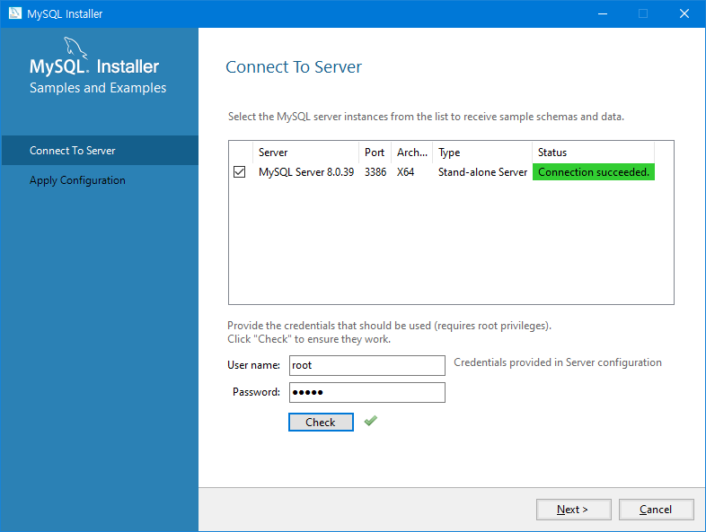

### Apply Configuration

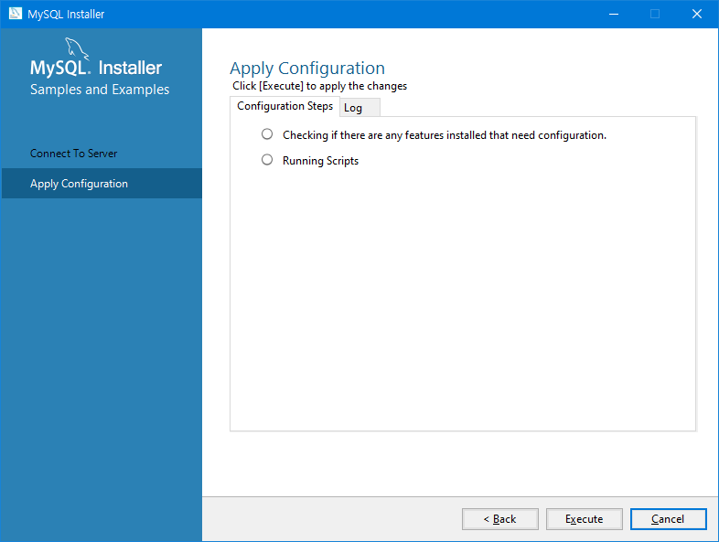

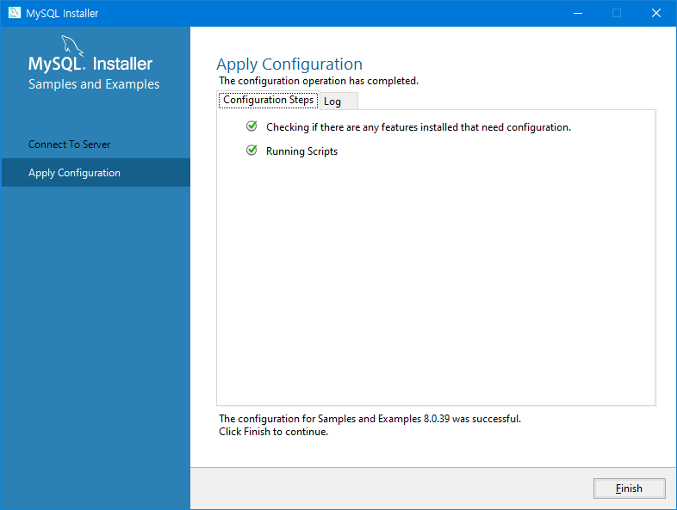

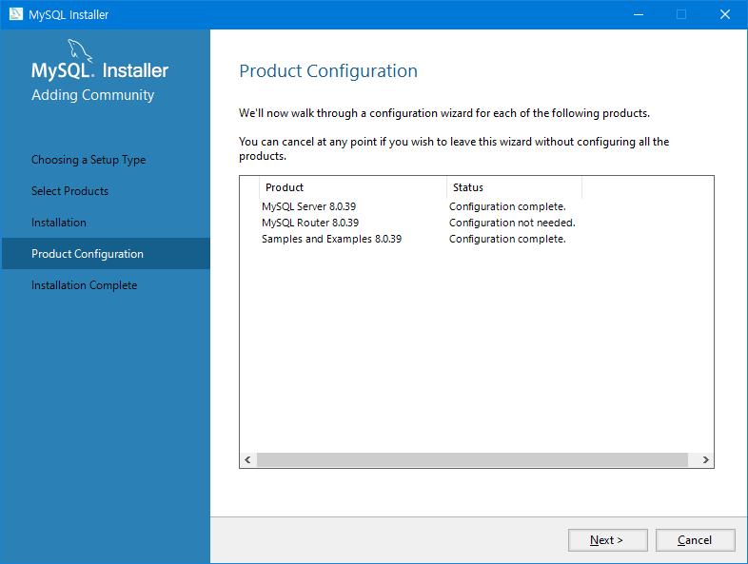

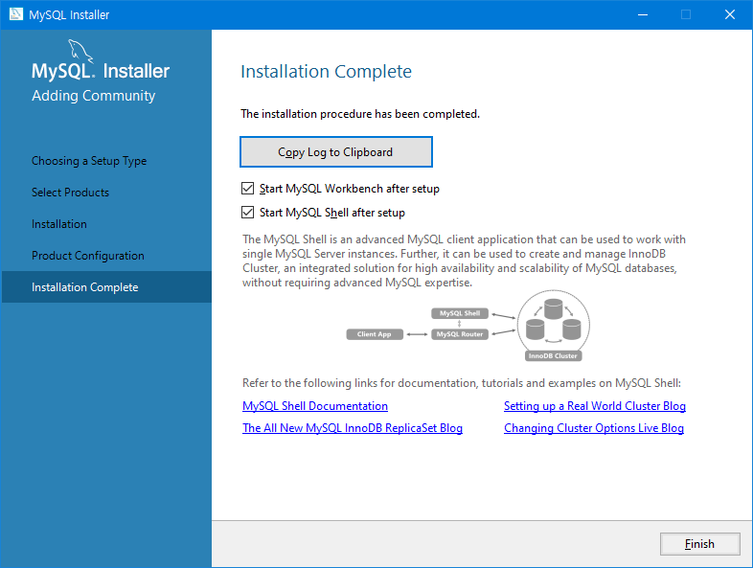

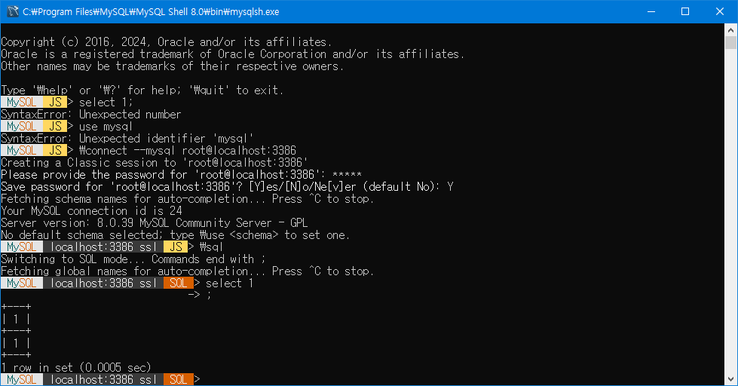

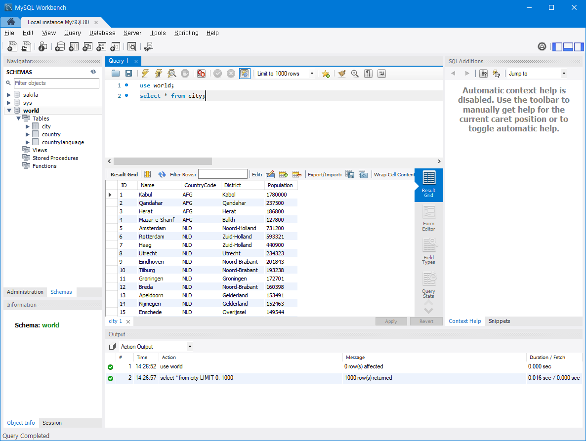

MariaDB 설치

# PostgreSQL 설치

cf. https://nazzang19.tistory.com/30

## 다운로드

download > <https://www.postgresql.org/download/windows/>

PostgreSQL Version 64 Bit Windows Platforms

16 2022, 2019

15 2019, 2016

https://www.enterprisedb.com/downloads/postgres-postgresql-downloads

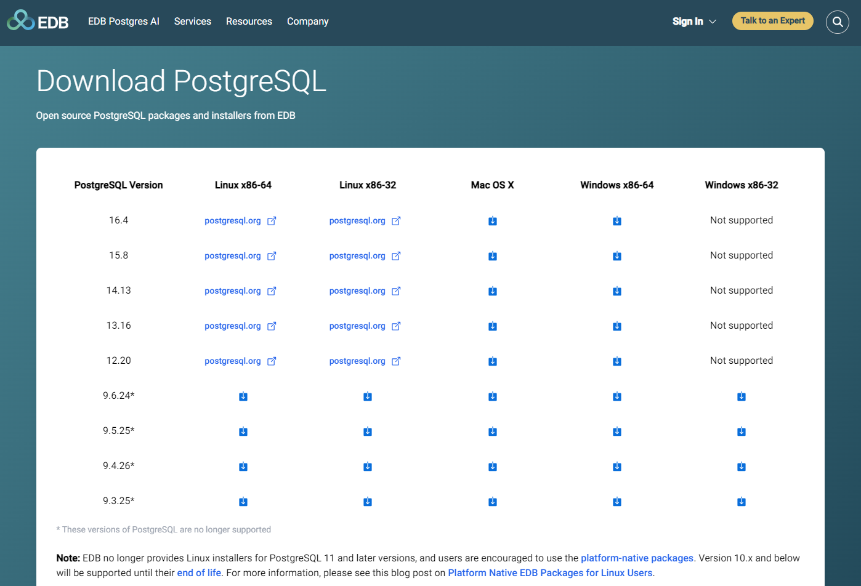

## Setup - PostgreSQL

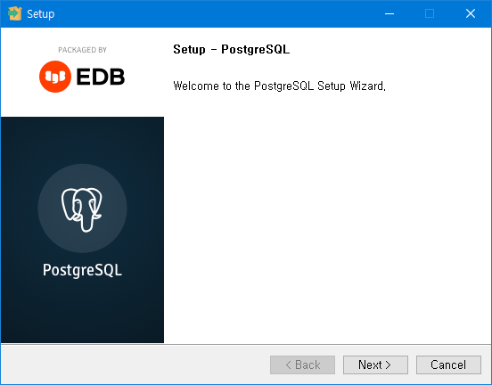

## Installation Directory

C:\Program Files\PostgreSQL\16

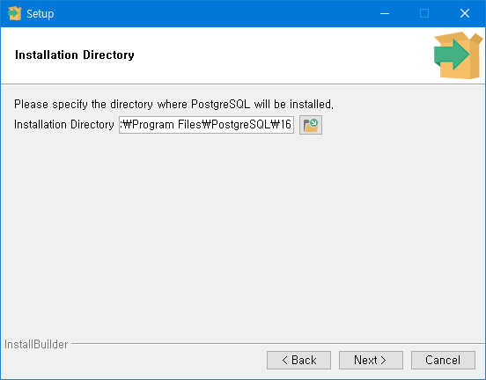

## Select Components

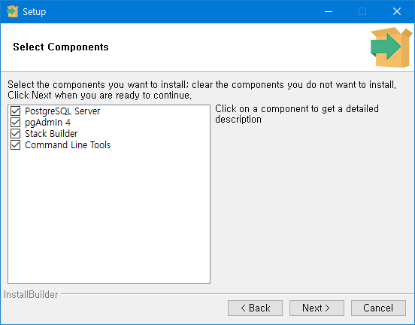

## Data Directory

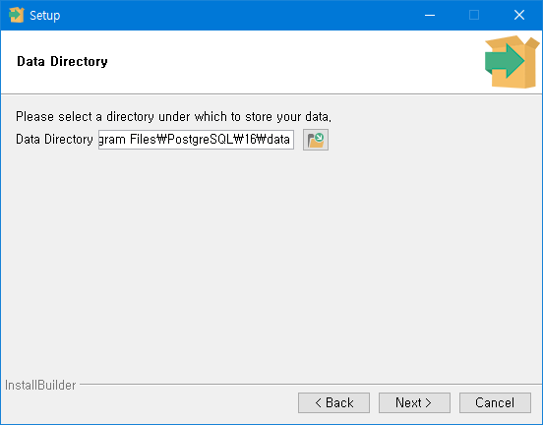

## Password

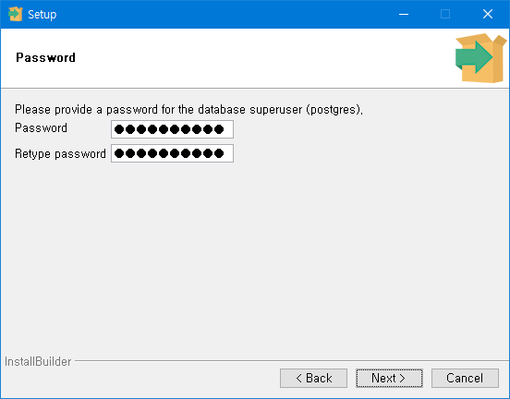

Password > postgresql

## Port

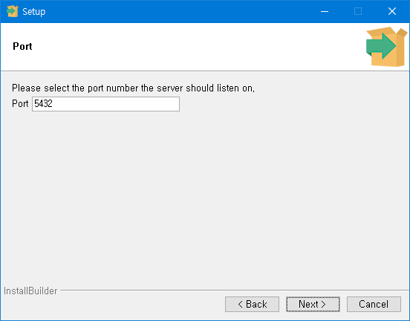

## Advanced Options : locale

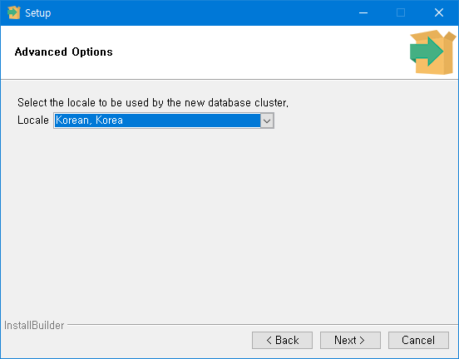

## Pre Installation Summary

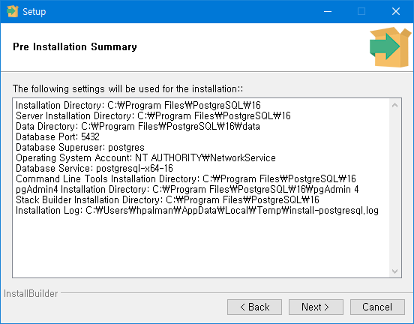

## Ready to install

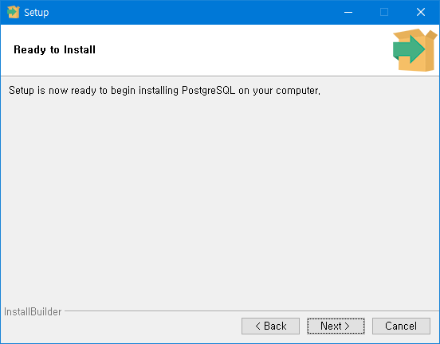

## Installing

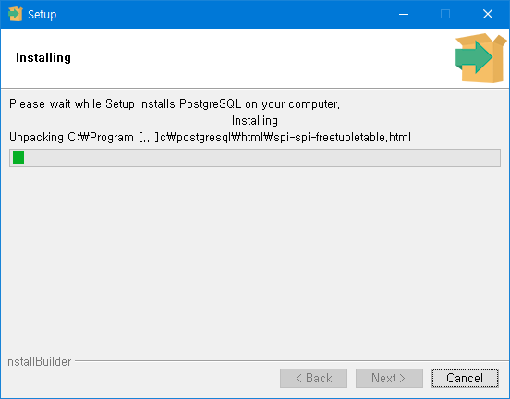

## Completing the PostgreSQL Setup Wizard

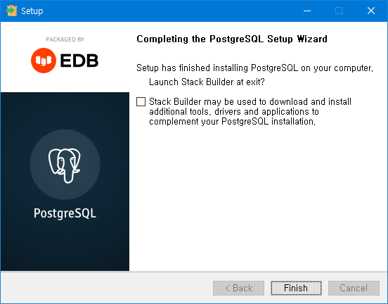

## pgAdmin 4



CREATE SEQUENCE MEMBER_SEQ;

CREATE TABLE MEMBER

(

SEQ BIGINT NOT NULL DEFAULT NEXTVAL('MEMBER_SEQ'),

ID VARCHAR(50) UNIQUE NOT NULL,

NAME VARCHAR(50) NOT NULL,

AGE INT NULL,

SEX_CD VARCHAR(1) NOT NULL,

CREATE_DATE TIMESTAMP,

UPDATE_DATE TIMESTAMP,

CONSTRAINT MEMBER_PK PRIMARY KEY (SEQ)

);